Validation1.html
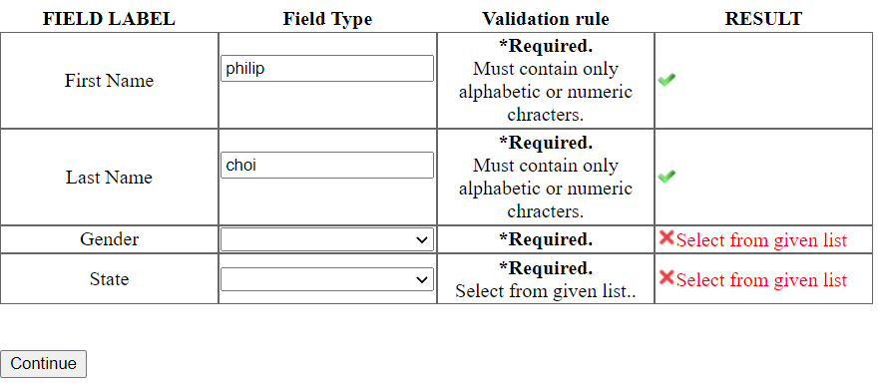 | Gender and state must be selected. Default blank would cause an error.
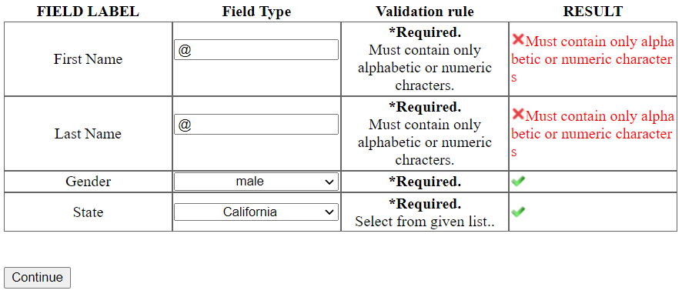 | First and Last name must be alphanumeric values.
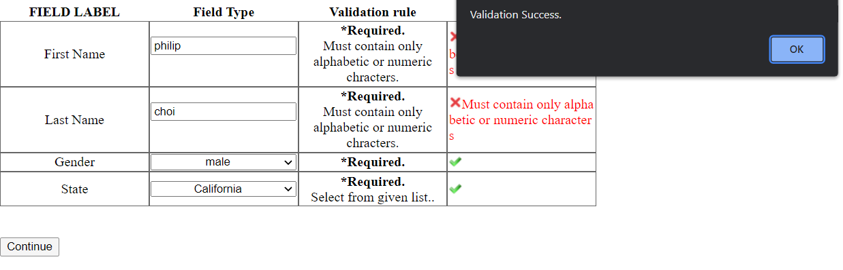 | When all values meet the requirements, a window pops up saying “validation success.”  Then, it transfers to validation2.html

Validation2.html
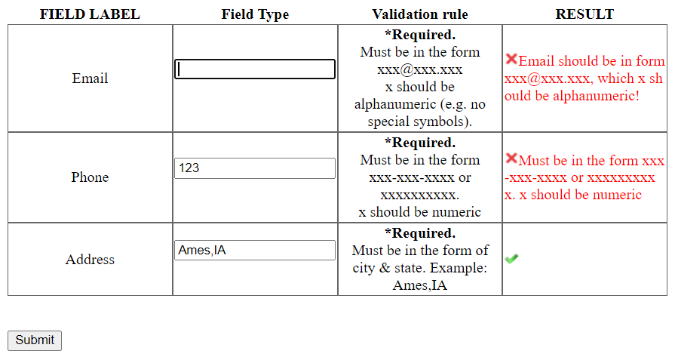 | Email must be in a form of xxx@xxx.xxx  And phone number must be in a form of either xxx-xxx-xxxx or xxxxxxxxxx (9digits)
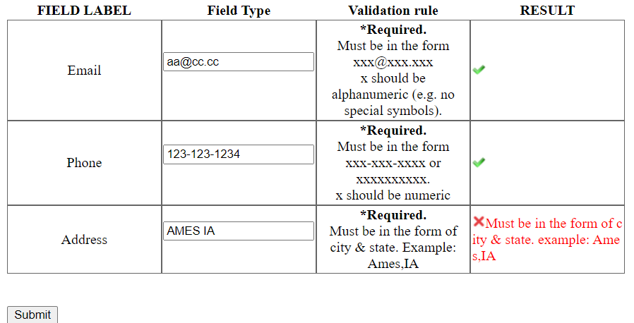 | Address must be in the (city),(state)
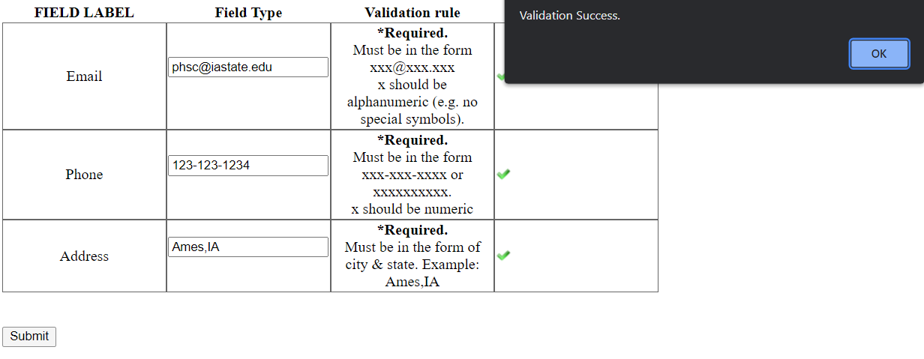 | When all values meet the requirements, a window pops up saying “validation success.”

